Reference Tutorial

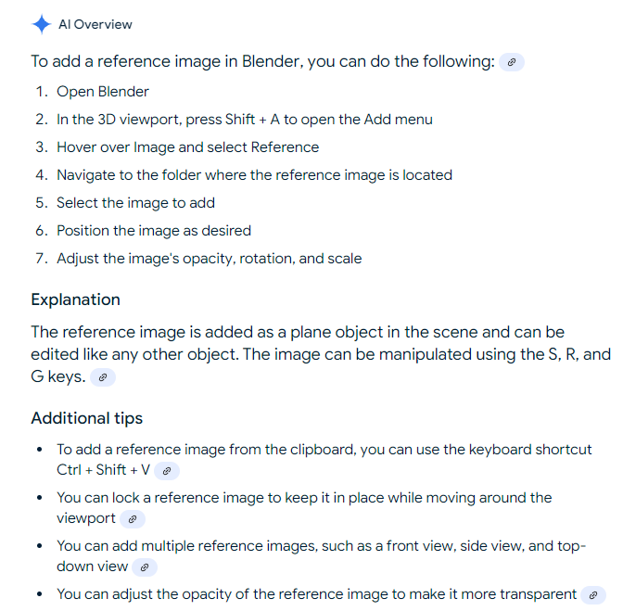

To bring in a reference image in Blender, while in the 3D viewport, press Shift + A to open the "Add" menu, then navigate to "Image" > "Reference"; this will allow you to select the desired image file which will appear as a plane object within your scene that you can position and adjust as needed.

Key points about using reference images in Blender:

* **Accessing the menu:** Use the keyboard shortcut "Shift + A" to access the "Add" menu.
* **Selecting "Reference":** Once in the "Add" menu, hover over "Image" and choose "Reference".
* **Image placement:** The reference image will be added as a plane object, allowing you to manipulate its position, rotation, and scale using the standard transformation tools (G, R, S).
* **Opacity control:** Adjust the opacity of the reference image to make it partially transparent, allowing you to see through it while modeling.

**Follow the below steps.**

1. While in Object Mode, use Numberpad 5 to toggle Orthographic View on.
2. Hit Numberpad 1 to align the viewport with your X and Z axis.
3. Click Add above or use Shift + A.
4. Hover over the Image pull-out and select Reference. ...
5. Use Numberpad 3 for a side view

~~~~~~~~~~~~~~~~~~~~~~~~~~~~~~~~~~~~~~~~~~~~~~~~~~~~~~~~~~~~~~~~~~~~~~~~~~~~~~

https://www.youtube.com/watch?v=kQa2o3tpV8U